Dear [Patient Name],

As a patient with lumbar spinal stenosis (LSS) in our practice, it’s important that you are aware of the additional treatment options we offer beyond epidural steroid injections (ESIs) that can put you on the path to lasting relief.

Have injections stopped working?
Although injections are a safe and effective treatment option, we know that they provide only temporary relief from LSS symptoms and often require repeat treatments to maintain comfort. If steroid injections have stopped providing adequate relief or you are interested in other options, your next step may be mild®.

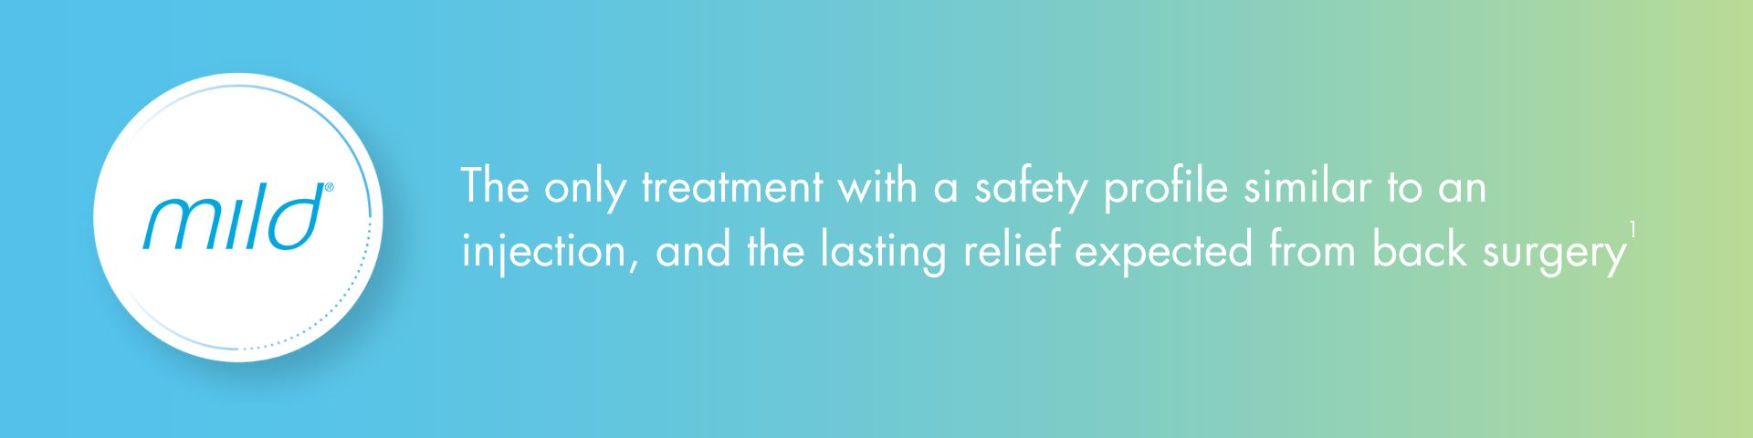

Is mild® right for you?
If you are still experiencing back and leg pain when you stand or walk, talk to our practice about whether the mild® Procedure may be right for you. Unlike injections, mild® treats LSS pain at its source instead of masking the symptoms temporarily.

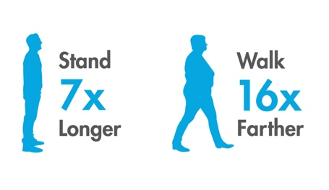
The procedure is generally performed in under an hour through an incision smaller than the size of a baby aspirin, and patients can typically resume normal activity within 24 hours with no restrictions.¹

Studies show that over one year mild® patients, on average, are able to stand 7X longer and walk 16X farther.¹

Schedule your consultation today.
If mild® sounds like the treatment option you’ve been searching for, schedule an appointment for evaluation and to learn more about the minimally invasive procedure.

[insert practice QR code/link to make a virtual appointment]
Warm regards,
[Physician & Practice Name]
[Contact Information]

