Dear [Referring Practice or Physician Name],
I hope this message finds you well. As a [Specialty] practicing in [Community], I wanted to reach out to make you aware of the comprehensive diagnostic and care options our practice provides for patients with chronic low back pain (CLBP), a condition that affects more than 1 in 4 U.S. adults.¹

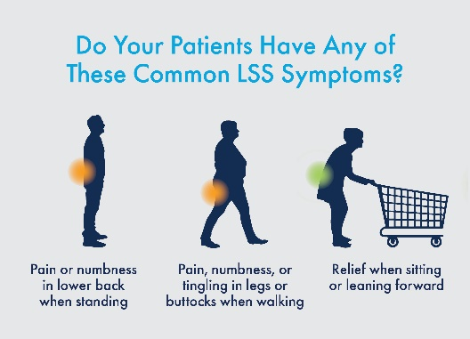
If your patients with CLBP are presenting with symptoms that include pain, numbness, and tingling in the back, legs, or buttocks, trouble walking or standing without rest, or finding relief when flexing forward or bending over, please send them to our practice for a diagnostic workup and treatment plan. These symptoms could be an indicator of lumbar spinal stenosis (LSS).

LSS patients have traditionally been treated with epidural steroid injections (ESIs), which as you likely know, provide only temporary relief from symptoms and often require repeat treatments to maintain effectiveness.

Our practice offers safe and effective treatment options. I would like to extend an invitation to refer to us any patients who may be experiencing CLBP-related symptoms. We specialize in offering clinically proven, durable treatment options including the mild® Procedure, a minimally invasive, outpatient option that addresses a major root cause of LSS by removing excess ligament tissue to restore space in the spinal canal.

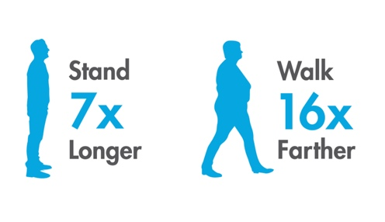
The mild® Procedure offers proven success in reducing pain and enhancing mobility, allowing patients to:

- Stand 7X longer²
- Walk 16X farther²
- Avoid back surgery for at least 5 years³

We can develop a customized treatment plan to optimize patient outcomes and ensure the best possible care. Thank you for your attention, and I look forward to working with you.

Please don't hesitate to reach out if you have any questions.

Warm regards,
[Physician & Practice Name]
[Contact Information]

